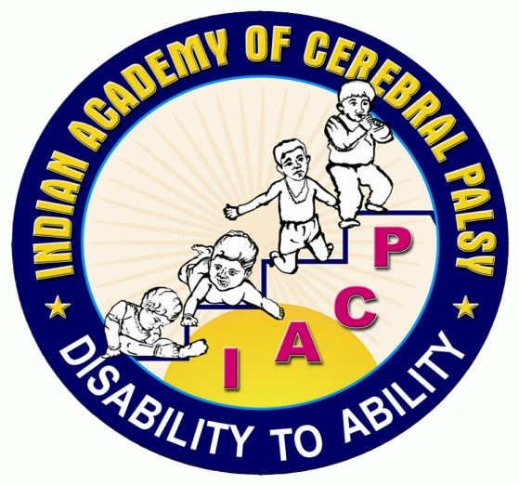

Indian Academy of Cerebral Palsy

Consensus Statement on Stem Cell Therapy in Cerebral Palsy
This is a consensus statement from the scientific & research committee group of IACP.AS per the national guidelines issued by ICMR on stem cell research & the general international consensus, Stem cell therapy in cerebral palsy is an unproven but promising translational research intervention which is still considered to be a clinical trial methodology. Translational research is the process used to turn scientific knowledge into real world treatments. It has lot more questions to answer than what it has answered till now & ongoing studies are underway .Till such time that we have an accepted evidence based medicine pronouncements, it is unethical to offer it as therapy. As per the latest National guidelines for stem cell research published by ICMR and DBT “any stem cell use in patients must only be done within the purview of an approved and monitored clinical trial with the intent to advance science and medicine, and not offering it as therapy. In accordance with this stringent definition, every use of stem cells in patients outside an approved clinical trialshall be considered as malpractice.”
Parents undergoing this form of intervention need to ask questions to those offering this intervention. Science has lot more obstacles before it becomes medicine. They can subject their children at their own risk, discretion & option.
IACP also declares that we are not part of any organization & institution offering this therapy & our scientific plat form has been misused by vested interests without official approval. We distance ourselves from all such spurious statements & offer no credibility to such claims as & when they are quoted by any one at any place.
This notice is issued in the interest of parents & children with cerebral palsy whose welfare is the guiding spirit of Indian Academy of cerebral palsy with approval from competent authorities. For more details, log on to following websites
- icmr.nic.in/About_Us/Guidelines.html
- Vib.nic.in/newsite/PrintRelease.aspx?relid=104095
- Department of Health Research (DHR), Government of India,www.dhr.gov.in/
- stemcells.nih.gov/
- www.eurostemcell.org ›
- ucp.org/resources/from-the-medical-director-s.../stem-cell-therapy/
- Stem Cell Treatments for Cerebral Palsy,Factsheet for patients and families,Crystal Ruff,* Jared Wilcox,* Michael Fehlings-Childhood disability LINK
- http://www.isscr.org/public
- http://www.ninds.nih.gov/disorders/cerebral_palsy/detail_cerebral_palsy.htmStem cell therapy
- isscr-Patient Handbook on Stem Cell Therapies,Appendix I of the Guidelines for theClinical Translation of Stem CellsDecember 3, 2008
- http://www.closerlookatstemcells.org/How_Science_Becomes_Medicine.html

